ENERS

Recruitment

Solution Design Document

Author: Evosys

Creation Date:

Last Updated:

Document Ref:

Version:

Approvals:

|  |  |
| --- | --- |
| ENERS Project Manager |  |
| ENERS HR Director |  |

**DOCUMENT CONTROL**

**Change Record**4

|  |  |  |  |
| --- | --- | --- | --- |
| Date | Author | Version | Change Reference |
|  | Evosys | 3.0 | Document Creation |

**Reviewers**

|  |  |
| --- | --- |
| Name | Position |
|  | Evosys Solution Architect |

1. Introduction 5

1.1. Stakeholder List 5

1.2. Abbreviations 5

2. Business Structure 6

2.1. Job Requisition 7

2.1.1. Requisition Number Generation 7

2.1.2. Recruiting Types 7

2.1.3. Requisition Form 7

2.1.4. Job Descriptions 9

2.1.5. Organization Hierarchy 9

2.1.6. Geography Structure and Hierarchy 9

2.2. Job Posting 10

2.2.1. Job Formatting Information 10

2.2.1.1. Employer Description 10

2.2.2. Job Boards 10

2.2.3. Agency 11

2.2.4. Career Site 11

2.3. Job Application 11

2.3.1. Job Application Statement (Privacy Statement) 11

2.3.2. Job Application Flow 11

2.3.3. Third-Party Plugins 12

2.3.4. Resume Parsing 12

2.3.5. Oracle AI application 12

2.3.6. Job Application Questions 12

2.3.6.1. Prescreening Questions 12

2.4. Candidate Selection Process 13

2.4.1. Phases and States 13

2.4.1.1.1. Withdrawal and Rejection Reasons 15

2.5. Interview Details 16

2.5.1. Interview Questions and Questionnaires 16

2.5.2. Interview Schedule Templates 18

2.6. Job Offer Templates 18

2.7. Standard Notifications 18

2.8. Pre-Onboarding Checklist 18

3. Security 19

3.1. Roles 19

3.2. Area of Responsibility 20

3.3. Role Provisioning 20

4. Business Process 20

4.1. Create Job Requisitions 22

4.2. Format and Post Job Requisitions 23

4.3. Source and Manage Candidates 25

4.4. Referral From Agent 26

4.5. Manage Candidate Pools 27

4.6. Manage Recruitment Campaigns 27

4.7. Refer Jobs 28

4.8. Search and Apply for Jobs 28

4.9. Manage Candidate Job Applications 30

4.10. Manage Interviews 31

4.11. Manage Job Offers 33

4.12. Manage Pre-boarding and Contract of Employment 34

4.13. Manage Security Clearance 35

5. Personalization 37

6. Open Points 37

7. Sign Off 38

# Introduction

This document presents the Future Process Model constructed for the HCM Process at ENERS. The Solution Design Document documents the triggering events that drive the business areas that are to be automated and describes the business process that the business executes in response to each of those events as a set of one or more activities. The document takes into account decisions made as part of the HLA sessions.

The Requirement Definition for the various Business Process Groups (Functional Workgroups) as formed during the HLA phase – Workshop approach. The key focus of this phase was as follows:

* Quick mapping and verification of processes wherein the practices followed by ENERS are in line with Oracle Standards.
* Clearly identifying the process flow to be followed in the system in future

Key User should be able to visualize the product and get used to the flow, terms and conventions and hence be able to contribute much higher in the training phases.

The objective of this document is to:

* Capture Solutions and Processes for the requirements mentioned by ENERS in the Design phase of the project
* This document also represents the business processes to be followed in ENERS henceforth.

This document includes a listing of all the business processes to be finalized, a detailed description of the process steps involved, either automated or manual, and supported by diagrammatic representations. The aim of this document is to consolidate all customer business processes.

## Stakeholder List

* ENERS Project Management Team
* ENERS HR Team Key Users
* Evosys Implementation Team

## Abbreviations

|  |  |  |
| --- | --- | --- |
| **Abbreviations** | **Full Form** | **Description** |
| **DFF** | Descriptive Flex Fields | Custom Fields |
| **AOR** | Area of Responsibility |  |

# Business Structure

In Cloud HCM, Business Structure is a backbone of the entire implementation. A thoroughly planned and calculated decision is required to design the system.

The core setup comprises the building blocks of the entire Application Design. This document contains a list of important Recruiting setups. These have been arrived through Business Workshops conducted to explain key structures. The setups contained in this document will be used for setting up the architecture for recruitment module.

|  |  |
| --- | --- |
| **Country** | **To be Implemented/ Integrated** |
| Finland | To be Implemented |
| Estonia | Not to be Implemented |
| Latvia | Not To be Implemented |
| Lithuania | Not To be Implemented |
| Germany | Not to be Implemented |
| France | Not to be Implemented |
| United Kingdom | Not to be Implemented |

## Job Requisition

### Requisition Number Generation

* Requisition Number Generation Method will be **Automatic** with Requisition Number Starting Value equals to 1 (One) for newly created requisitions.
* Requisition Number Generation Method will be **Manual** for the open requisitions to be migrated during cut-off. Requisition number will be alphanumeric. For ex. SYS_CODE_REQUISITION_NUMBER.

### Recruiting Types

Below recruiting types will be used for ENERS:

* Office Worker
* Field Worker
* Customer Project Worker
* Trainee
* External Project

### Collaborator Types

Below collaborator types will be used for ENERS:

* + Collaborator
  + Mobilization Team
  + Division Head/Hiring Manager
  + Client

### Requisition Form

|  |  |  |  |  |  |
| --- | --- | --- | --- | --- | --- |
| **Section name** | **Field name** | **Placeholder** | **Field** | **LOV** | **Mandatory** |
| HOW | Requisition Type | Requisition | Standard field | Standard | No |
| Use | Requisition | Standard field | Template | Yes |
| Job |
| Blank Requisition |
| Existing Requisition |
| Business Unit | Requisition | Standard field | LOV coming from core HR | Yes |
| Job | Requisition | Standard field | LOV coming from core HR | Yes |
| Basic Info | Requisition Status | Requisition | Standard field | Draft - In Progress | No |
| Requisition Type | Requisition | Standard field | Standard | No |
| Requisition Title | Requisition | Standard field | Textbox | Yes |
| Number of openings | Requisition | Standard field | Textbox | Yes |
| Business Justification | Requisition | Standard field | New position | No |
| Replacement |
| Languages | Requisition | Standard field | LOV | No |
| Comments | Requisition | Standard field | Textbox | No |
| Hiring Team | Hiring manager | Requisition | Standard field | LOV coming from core HR | Yes |
| Recruiter | Requisition | Standard field | LOV based on AOR | Yes |
| Collaborator | Requisition | Standard field | LOV of workers | No |
| Requisition Structure | Organization | Requisition | Standard field | Value fetching from Recruiting Organization name | Yes |
| Recruiting Type | Requisition | Standard field | Office Worker | Yes |
| Field Worker |
| Customer Project Worker |
| Trainee |
| External Project |
| Primary location | Requisition | Standard field | LOV from geography structure | Yes |
| Other Locations | Requisition | Standard field | LOV from geography structure | No |
| Details | Worker type | Requisition | Standard field | Contingent worker | No |
| Employee |
| Regular or Temporary | Requisition | Standard field | Regular | No |
| Temporary |
| Full time or part time | Requisition | Standard field | Full time | No |
| Part time |
| Job Type | Requisition | Standard field | Co-op | No |
| Internship |
| Standard |
| Summer |
| Education Level | Requisition | Standard field | LOV coming from core HR | No |
| Pay Frequency | Requisition | Standard field | LOV coming from core HR | No |
| Maximum Salary | Requisition | Standard field | text field | No |
| Minimum salary | Requisition | Standard field | text field | No |
| Employee Referral Bonus | Requisition | Standard field | Text field | No |
| Client Company Name | Requisition | DFF | Text field | No |
| Contract type | Requisition | DFF | LOV | Fixed Term  Time Being |
| Other Options (taxable fringe benefits): | Requisition | DFF | Text Field | No |
| Posting Description | Job description (Education, Technical skills, soft skills, certificates, languages, required relevant experience | Requisition | Standard field | Text field | No |
| Offer | Legal Employer | Requisition | Standard field | LOV from core HR | No |
| Business Unit | Requisition | Standard field | Non editable | No |
| Department | Requisition | Standard field | LOV from core HR | No |
| Primary Work Location | Requisition | Standard field | LOV from core HR | No |
| Other Work Location | Requisition | Standard field | LOV from core HR | No |
| Job | Requisition | Standard field | LOV from core HR | No |
| Attachment | | Requisition | Standard field |  | No |
| Configuration | Candidate Selection Process | Requisition | Standard field | List of values | Yes |
| External Application Flow | Requisition | Standard field | List of values | Yes |
| External Application Flow | Requisition | Standard field | Yes | No |
| No |  |
| Automatically Fill Requisition | Requisition | Standard field | Yes | No |
| No |  |
| Questionnaires | Internal Prescreening Questionnaire | Requisition | Standard field | List of values | No |
| External Prescreening Questionnaire | Requisition | Standard field | List of values | No |
| Interview Questionnaires | Requisition | Standard field | List of values | No |

### Job Descriptions

Job descriptions to be stored which can be selected from the drop down and made changes to. Job posting templates

### Organization Hierarchy

The Organization Tree for Recruiting whilst being the same as Core HR will not display all the elements that are displayed in Core HR. Recruiting organization tree will be based on Legal entity. Organization serves as one of the contextualization elements in Oracle Recruiting Cloud. Oracle Recruiting Cloud can have a separate Organization Tree than Core HCM module. This helps in seeing only the relevant organizations while creating requisition templates, requisitions, questions, etc. which help in proper contextualization.

**Note: Organization Hierarchy will have one single node- ENERS**

### Geography Structure and Hierarchy

A geography hierarchy is a business object that defines a limited universe of geographies, organized in parent-child relationships. Oracle Recruiting uses geographies managed in HCM.

A geography hierarchy structure can have a maximum of two levels. The topmost level represents the country. For each country, a maximum of two geography sublevels can be defined:

* Level 1
* Level 2

|  |  |  |  |
| --- | --- | --- | --- |
| **Country Code** | **Country Name** | **Level 1** | **Level 2** |
| FI | Finland | City | Postal Code |

**Note**: As per the discussion, primary location list will have all possible countries for external project worker hiring

## Job Posting

### Job Formatting Information

When the job requisition is approved, the Job Formatting tab becomes available. This is where you select descriptions and media you want to share with candidates.

#### Employer Description

Description of the employer the candidate will apply for:

*“ENERS International Plc is a provider of zero-emission energy solutions. The company is strongly involved in supporting the ongoing energy transition and enabling a zero-emission society. The ENERS Group’s turnover in 2020 was around EUR 144 million. The pro forma turnover of the ENERS-Empower Group, which was consolidated in 2020, was around EUR 241 million in 2020. The company has around 2,400 employees, and it operates in Finland and internationally in around 40 countries. ENERS’s share is listed on Nasdaq Helsinki (ESENSE). The company’s website for investors can be found at www.ENERS.com/investors.*

*As an ENERS employee, you will be provided with comprehensive occupational health care and seasonally changing benefits with our partners. We support and assist you throughout your employment, including in various logistical matters. We want you to be successful and have the possibility to develop yourself on your career path. If you wish to get a boost for your career, submit your application today.”*

***Note****: This will be changed later if required.*

### Job Boards

* Job Boards are external portals where jobs can be posted which are also available for external candidates to apply. Upon applying they will then be redirected to the external careers section to provide their details.
* Job Boards can be integrated with Oracle Recruiting Cloud via an Oracle job aggregator partner such as **eQuest**.
* List of Job boards: <Open Point: IN-18069>

|  |  |  |
| --- | --- | --- |
| Country | Name | Job Board |
| Finland | Työmarkkinatori |  |
| Finland | Energyjobline |  |
| Finland | Oikotie |  |
| Finland | Duunitori |  |
| Finland | LinkedIn |  |
| Finland | Indeed |  |

### Agency

* The jobs can also be posted to the agents of different agencies. The agents would receive an email and then they can login into the system to submit the applicants on the requisition.
* Using agencies is optional for all countries.
* Agency details are not available as of now.

### Career Site

A career site is a website where an ENERS will post jobs for positions to be filled. External candidates interact with a career site when they search for jobs, apply for jobs, create a profile, share job details, get referred for a job, manage their job applications and talent community settings.

* + One Global Career Site will be enabled to feed to the ENERS.com site.
  + Career Site Branding <Open Point: IN-18438>
  + Detailed Descripted Question for Digitital Assistant

## Job Application

### Job Application Statement (Privacy Statement)

Instructions displayed to candidates when they provide their electronic signature as part of the candidate's application process. Here is latest privacy policy in English and Finnish languages.

Privacy Policy (English)

Privacy Policy (Finnish)

### Job Application Flow

A job application flow is a sequence of pages that candidates complete when they apply for a job. A job application flow contains sections, and each section contains blocks of information.

|  |  |  |  |  |
| --- | --- | --- | --- | --- |
| **Section name** | **Field Name** | **Field Type** | **Field Values** | **Mandatory** |
| Personal Information | Last Name | Text Field | | Yes |
| First Name | Text Field | | Yes |
| Title | Dropdown | Mr. | No |
| Ms. |
| Middle Name | Text Field | | No |
| Email Address | Text Field | | Yes |
| Phone Number | Text Field | | No |
| Diversity Information (Disclaimer: Gender information is asked in order to promote gender diversity and equality in the workplace. ENERS welcomes applications from all gender identities. If you wish, you may choose not to answer this question) | Gender | Dropdown | Male | No |
| Female |
| Prefer not to specify |
| Job Application Questions | Prescreening Questions | List of questions |  | No |
| Supporting documents | Resume | Attachment |  | No |
| Cover letter | Attachment |  | No |
| Legal disclaimer | | | | |
| E-signature | Full Name | Free text |  | Yes |

### Third-Party Plugins

|  |  |  |
| --- | --- | --- |
| Plugin | Description | To be Enabled |
| Apply with LinkedIn | Plugin that ENERS will enable on their external career site to allow candidates to apply with their LinkedIn profiles. | Yes |
| Apply with Indeed | Plugin that ENERS will enable on their external career site to allow candidates to apply with their Indeed profiles. | Yes |

Third Party Plugins to be enabled for profile import:

### Resume Parsing

No third-party application will be enabled for resume parsing as of now.

### Oracle AI application

The AI App uses machine learning and artificial intelligence algorithm to provide following features for recruiters and candidates:

**For recruiters:**

* HR data, including applicant, candidate, employee, and job requisition data from Oracle Recruiting Cloud.
* Recruiters’ decisions at each hiring stage.
* Feedback on recommendations received by the model to continually improve recommendations.

**For Candidates:**

* Recommended Jobs: Recommend additional jobs that match a candidate's profile.
* Similar Jobs: Recommend additional jobs similar to the selected job requisition.

Oracle AI application works more efficiently with more and consistent data in the system Job Application Questions

#### Prescreening Questions

To find out the best fit candidate for the job then pre-screening questions are created.

|  |  |  |  |  |  |  |
| --- | --- | --- | --- | --- | --- | --- |
| **Question** | **Response type** | **Answer** | **Required** | **Country** | **Question Classification** | **Candidate Type** |
|
| Availability date to start working? | Text box |  | No | All | Pre-screening Question Added by User | Both |
| What are your salary expectations per month or yearly including holiday allowance? | Text box |  | No | All | Pre-screening Question Added by User | Both |
| Are you authorised to work in the country? | List of Values | Yes, I am currently eligible to work (work permit/visa/citizenship) in the country to which I am applying. | Yes | All | Pre-screening Question Added by User | Both |
| No, I am not currently eligible to work (work permit/visa/citizenship) in the country to which I am applying. |
| Do you have a Valid driving license | List of values | Yes | No | All | Pre-screening Question Added by User | Both |
| No |
|  |  |  |  |  |  |  |
|  |
|  |  |  |  |  |  |  |
| Please fill home country: | Text Box |  | Yes | All | Prescreening Question Added Automatically | Both |
| Please provide extra details about your experience and qualifications | Text Box |  | No | All | Prescreening Question Added Automatically | Both |

## Candidate Selection Process

### ENERS Candidate Selection Process Phases and States

The below table defines candidate selection process which a candidate will go through once they have successfully confirmed their application. When candidates reach various phases in Candidate Selection Process, system auto- emails are triggered.

|  |  |  |  |  |  |
| --- | --- | --- | --- | --- | --- |
| **Phases** | **New** | **Screening** | **Interview** | **Offer** | **HR (Move to HR) (Mandatory)** |
| **(Optional)** | **(Optional)** | **(Optional)** | **(Optional)** |
| **States** | To be Reviewed | To be Reviewed | Interview to be scheduled | Offer to be created | To be Processed |
| Reviewed | Reviewed | Interview scheduled (Send Interview Invite) | Draft | Processing |
| Under Consideration | Phone screen to be scheduled | Feedback Requested (Move to Interview completed when all feedback has been received) | Pending Approval | Processed |
| Selected for Screening | Phone screen scheduled | Interview completed (Send Notification) | Approval rejected | Rejected by Employer |
| Rejected by Employer | Phone screen completed | Selected during an Interview | Approved | Withdrawn by candidate |
| Withdrawn by candidate | Selected for Interview | Feedback completed | Extended |  |
|  | Rejected by Employer | Candidate Feedback (Action: Request Info to collect feedback from candidate) | Rejected |  |
|  | Withdrawn by candidate | Reference Check (Action: Request Info to collect Reference details from candidate) | Rejected by Employer |  |
|  |  | Selected for Offer (Action: Request Info for NID as attachment) | Withdrawn by candidate |  |
|  |  | Offer Accepted (Action: Request Info for NID) |  |  |
|  |  | Request additional document (Action: Request Info to collect all documents) |  |  |
|  |  | Initiate security clearance |  |  |
|  |  | Rejected by Employer |  |  |
|  |  | Withdrawn by candidate |  |  |
|  |  |  |  |  |

|  |  |  |
| --- | --- | --- |
| **Process** | **Process Description** | **System or Manual** |
| 01_Selection_Process | Candidates will land on a New – To be Reviewed phase and state, once they apply for a job opening. | System |
| 02_Selection_Process | Recruiters can view candidate details and check if candidate is suitable to move ahead in the selection process | System |
| 03_Selection_Process | If the candidate is not suitable then the candidate can be rejected by employer at any phase | System |
| 04_Selection_Process | If a candidate is suitable/best fit for the job, then recruiter can move candidate to screening phase | System |
| 05_Selection_Process | After completing screening phase, Recruiter will now move Candide to interview phase | System |
| 06_Selection_Process | The recruiter will need to add a Candidate Managed Interview template on a requisition level | System |
| 07_Selection_Process | Recruiter will move candidate to Interview Schedule state | System |
| 08_Selection_Process | From under the Actions button, recruiter will select Send Interview Invite to automatically schedule an interview with the candidate. | System |
| 09_Selection_Process | Interviewer will take the interview of candidate | Manual |
| 10_Selection_Process | Recruiters will then send out questionnaires to all interviewers to collect feedback of the candidate. | System |
| 11_Selection_Process | Once all the feedback has been submitted by the interviewers, Recruiter can then move the candidate to Feedback Requested State | System |
| 12_Selection_Process | Feedback requested state will then automatically move candidate to Interview Completed state (pre-requisite: to receive all feedback from interviewers) | System |
| 13_Selection_Process | Recruiter will then receive automated notification of interview completion on Interview Completed state | System |
| 15_Selection_Process | If the recruiter wishes to collect feedback from specific candidate, then recruiter need to move candidate to “candidate feedback” state under interview | System |
| 16_Selection_Process | This will trigger an email to the candidate to fill in an interview feedback questionnaire. | System |
| 17_Selection_Process | Candidate will respond to questionnaire | Manual |
| 18_Selection_Process | The recruiter will then move the candidate to the next state Reference Check to collect Reference information. This will trigger mail to candidate to submit Reference details | System |
| 19_Selection_Process | If the candidate has cleared the interview, recruiter will move the candidate to Interview- Selected for Offer.  This will trigger an email to the candidate to collect a copy of their national identifier | System |
| 20_Selection_Process | After receiving the NID details from the candidate, the recruiter will manually check NID details | Manual |
| 21_Selection_Process | Recruiter will then go to send message work area. | System |
| 22_Selection_Process | The recruiter will create and submit offer details and send it to the candidate | System |
| 23_Selection_Process | Candidates will receive email notification about the offer, if sent.  Candidate will respond to offer via mail to recruiter mail id | Manual |
| 24_Selection_Process | If an offer has been accepted by the candidate, the recruiter can copy the candidate response on the offer and paste it on the interaction tab | System |
| 25_Selection_Process | If the candidate has accepted the offer, then recruiter can now move the candidate to next state, Offer Accepted | System |
| 26_Selection_Process | The Offer Accepted state will trigger mail to candidate to submit national identifier details | System |
| 27_Selection_Process | Recruiter will now move candidate to Request additional documents.  This will trigger email to candidate to submit all document (passport, education, qualification details and Occupational health and safety card, visa details, address proof etc.) | System |
| 28_Selection_Process | The recruiter will receive the documents and will verify all the documents | System |
| 29_Selection_Process | Recruiter will then move candidate to Initiate security clearance state | System |
| 30_Selection_Process | Recruiter will now click on Actions button and will select Send message to My Team to send automated message to mobilization team added on a requisition as collaborators | System |
| 31_Selection_Process | Mobilization team will then again send message to candidate to take their consent for initiating security clearance/drug test/criminal record | Manual |
| 32_Selection_Process | Once the candidate fills in a consent form and submits it back to the mobilization team via email. | Manual |
| 33_Selection_Process | Mobilization team will take the task manually and wait for the response | Manual |
| 34_Selection_Process | If security clearance is not required or the result of security clearance gets passed, then recruiter will move candidate to Offer Phase | System |
| 35_Selection_Process | If the security clearance/drug test/ Criminal Record is failed then contract will be Cancelled. | System |
| 36_Selection_Process | Before submitting the final contract to the candidate, the recruiter will manually send Draft contract to candidate via email | Manual |
| 37_Selection_Process | On Offer phase, recruiter will generate employee draft agreement/contract and will save and close | System |
| 38_Selection_Process | Recruiter will preview offer letter and download draft version and send it to candidate via mail (offline) | System |
| 39Selection_Process | Once candidate will accept draft version of the job offer, then only the recruiter will generate the final contract | Manual |
| 40_Selection_Process | On Offer phase, recruiter will generate employee final agreement/contract and will extend it to candidate | System |
| 41_Selection_Process | Candidates will receive email notification about agreement details and candidate either Accept or Reject the agreement | System |
| 42_Selection_Process | If the agreement is rejected by the candidate, then recruiter can either redraft the agreement and again submit for candidate approval or delete job application | System |
| 43_Selection_Process | If the agreement is accepted by the candidate, then recruiter will move the candidate to next phase “Move to HR”.  This will convert the candidate to pending worker | System |

### Client Hiring Pipeline Phases and States

|  |  |  |  |
| --- | --- | --- | --- |
| **Phases** | **New** | **Screening** | **Interview** |
| **(Optional)** | **(Optional)** | **(Optional)** |
| **States** | To be Reviewed | To be Reviewed | Interview to be scheduled |
| Reviewed | Reviewed | Interview scheduled (Send Interview Invite) |
| Under Consideration | Phone screen to be scheduled | Feedback Requested (Move to Interview completed when all feedback has been received) |
| Selected for Screening | Phone screen scheduled | Interview completed (Send Notification) |
| Rejected by Employer | Phone screen completed | Selected during an Interview |
| Withdrawn by candidate | Selected for Interview | Feedback completed |
|  | Rejected by Employer | Candidate Feedback (Action: Request Info to collect feedback from candidate) |
|  | Withdrawn by candidate | Reference Check (Action: Request Info to collect Reference details from candidate) |
|  |  | Selected for Offer (Action: Request Info for NID as attachment) |
|  |  | Offer Accepted (Action: Request Info for NID) |
|  |  | Request additional document (Action: Request Info to collect all documents) |
|  |  | Rejected by Employer |
|  |  | Withdrawn by candidate |
|  |  |  |
|  |  |  |

|  |  |  |
| --- | --- | --- |
| **Process** | **Process Description** | **System or Manual** |
| 01_Pipeline_Selection_Process | In case of External Project hiring, Recruiter will have to select Pipeline Candidate Selection Process, which will consist of all Phase and state except Offer and HR | System |
| 02_Pipeline_Selection_Proces | Candidates will land on a New – To be Reviewed phase and state, once they apply for a job opening. |  |
| 03_Pipeline_Selection_Proces | Recruiters can view candidate details and check if candidate is suitable to move ahead in the selection process | System |
| 04_Pipeline_Selection_Proces | If the candidate is not suitable then the candidate can be rejected by employer at any phase | System |
| 05_Pipeline_Selection_Proces | If a candidate is suitable/best fit for the job, then recruiter can move candidate to screening phase | System |
| 06_Pipeline_Selection_Proces | After completing screening phase, Recruiter will now move Candide to interview phase | System |
| 07_Pipeline_Selection_Proces | The recruiter will need to add a Candidate Managed Interview template on a requisition level | System |
| 08_Pipeline_Selection_Proces | Recruiter will move candidate to Interview Schedule state | System |
| 09_Pipeline_Selection_Proces | From under the Actions button, recruiter will select Send Interview Invite to automatically schedule an interview with the candidate. | System |
| 10_Pipeline_Selection_Proces | Interviewer will take the interview of candidate | Manual |
| 10_Pipeline_Selection_Proces | Recruiters will then send out questionnaires to all interviewers to collect feedback of the candidate. | System |
| 10_Pipeline_Selection_Proces | Once all the feedback has been submitted by the interviewers, Recruiter can then move the candidate to Feedback Requested State | System |
| 10_Pipeline_Selection_Proces | Feedback requested state will then automatically move candidate to Interview Completed state (pre-requisite: to receive all feedback from interviewers) | System |
| 10_Pipeline_Selection_Proces | Recruiter will then receive automated notification of interview completion on Interview Completed state | System |
| 12_Pipeline_Selection_Proces | If the recruiter wishes to collect feedback from specific candidate, then recruiter need to move candidate to “candidate feedback” state under interview | System |
| 13_Pipeline_Selection_Proces | This will trigger an email to the candidate to fill in an interview feedback questionnaire. | System |
| 14_Pipeline_Selection_Proces | Candidate will respond to questionnaire | Manual |
| 15_Pipeline_Selection_Proces | Recruiter will then move candidate to next state Reference Check to collect Reference information. This will trigger mail to candidate to submit Reference details |  |
| 16_Pipeline_Selection_Proces | If the candidate has cleared the interview, recruiter will move the candidate to Interview- Selected for Offer.   This will trigger an email to the candidate to collect national identifier details as attachment | System |
| 17_Pipeline_Selection_Proces | After receiving the NID details from the candidate, the recruiter will manually check NID details | Manual |
| 18_Pipeline_Selection_Proces | Recruiter will then go to send message work area. | System |
| 19_Pipeline_Selection_Proces | The recruiter will create and submit offer details and send it to the candidate | System |
| 20_Pipeline_Selection_Proces | Candidates will receive email notification about the offer, if sent.  Candidate will respond to offer via mail to recruiter mail id | Manual |
| 21_Pipeline_Selection_Proces | If an offer has been accepted by the candidate, the recruiter can copy the candidate response on the offer and paste it on the interaction tab | System |
| 22_Pipeline_Selection_Proces | If the candidate has accepted the offer, then recruiter can now move the candidate to next state, Offer Accepted |  |
| 23_Pipeline_Selection_Proces | Offer Accepted state will trigger mail to candidate to submit national identifier details |  |
| 24_Pipeline_Selection_Proces | Recruiter will now move candidate to Request additional documents.   This will trigger email to candidate to submit all document (passport, education, qualification details and Occupational health and safety card, visa details, address proof etc.) | System |
| 25_Pipeline_Selection_Proces | The recruiter will receive the documents and will verify all the documents | System |
| 26_Pipeline_Selection_Proces | Contract formation and sending final contract to candidate will be an offline process | System |

#### Withdrawal and Rejection Reasons

* + - List of reasons: Reasons

**2.4.3**. **Candidate RMI (Request More Information) Flow**

The below fields would be triggered as a part of RMI (Request More Information) flow to the candidate, when the candidate is moved to “Interview - Selected for Offer” phase and state. Please note the value entered in these fields would automatically be passed to Core HR upon Move to HR action.

|  |  |  |  |
| --- | --- | --- | --- |
| **Section Name** | | | |
| **Sensitive Personal Information** | | | |
| **Field Name** | **Field Type** | **Mandatory** | **Possible Values** |
| Add National Identifier –Country | Dropdown | Yes | List of all seeded Countries |
| National ID Type | Dropdown | Yes | Depends on Country selected. For Country-National ID Type mapping refer Core HR section in the SDD |
| National ID | Text Field | Yes | It triggers seeded validations based on National ID type |
| Issue Date | Dropdown | No | Month and Year LOV would be available |
| Expiration Date | Dropdown | No | Month and Year LOV would be available |
| Place of Issue | Dropdown | No |  |
| **National Identifier** | Attachment | No |  |
| **Passport Details** | Attachment | No |  |
| **Visa Details** | Attachment | No |  |
| Address Proof (home address and address in Finland) | Attachment | No |  |
| **License and Certification** |  |  |  |
| License or Certificate | Dropdown | Yes | List of all ENERS Certificate |
| Country | Dropdown | No | List of all seeded Countries |
| Issued By | Text Field | No |  |
| Certificate Number | Text Field | No |  |
| Issue Date | Text Field | No |  |
| Original Issue Year | Text Field | No |  |
| Expiration Date | Text Field | No |  |
| Renewal Date | Text Field | No |  |
| Renewal Required | Dropdown | No | Yes or No |
| Actual Completion Date | Text Field | No |  |
| Status | Dropdown | No | Active or Expired or Renewal in Progress |
| Verified | Dropdown | No | Yes or No |
| Title | Text Field | No |  |
| **Reference Check** |  |  |  |
| Reference Name | Text Field | No |  |
| Contact Details | Text Field | No |  |
| Company Details | Text Field | No |  |
| Designation | Text Field | No |  |

List of ID’s (at least one) need to be captured as National Identifier: -

* + Finnish ID number
  + Finnish Tax number (12 digits, starts with 1000…)
  + Personal ID number in home country

## Interview Details

### Interview Questions and Questionnaires

Interview Guidelines : Interview Guideline for candidates

Interview feedback forms are created to collect the interview feedback from the interviewers about the candidate. ENERS Interview feedback form is as follows:

|  |  |  |  |  |
| --- | --- | --- | --- | --- |
| **Question** | **Response type** | **Answer** | **Required** | **Country** |
| Level of preparation | List of Values | Poor, Fair, Ok, Good, Excellent | Yes | All |
| Relevant prior experience: | List of Values | Poor, Fair, Ok, Good, Excellent | Yes | All |
| Relevant qualifications / training: | List of Values | Poor, Fair, Ok, Good, Excellent | Yes | All |
| Attitude and motivation: | List of Values | Poor, Fair, Ok, Good, Excellent | Yes | All |
| General interest in company and role: | List of Values | Poor, Fair, Ok, Good, Excellent | Yes | All |
| Communication / listening skills: | List of Values | Poor, Fair, Ok, Good, Excellent | Yes | All |
| Reasons for recommendation to fill the applied position: | Text box |  | Yes | All |
| ADDITIONAL INFORMATION: (Not included in the CV but belonging to the current position and good to mention to our clients) | Text box |  | Yes | All |
| REASON(S) FOR JOB CHANGING: | Text box |  | Yes | All |
| Recommendation for next round of Interview | List of Values | 1) Yes  2) No | Yes | All |

Candidate Experience Form: -

|  |  |  |  |  |
| --- | --- | --- | --- | --- |
| **Candidate Experience Form questions:** | **Response Type** | | | |
| 1. Application process was easy. | Strongly Agree | Agree | Disagree | Strongly Disagree |
| 2. Communication with the Recruiter was smooth. | Strongly Agree | Agree | Disagree | Strongly Disagree |
| 3. Was the job description presented to you in line with the information given to you in the interview? | Strongly Agree | Agree | Disagree | Strongly Disagree |
| 4. My Interviewers were well prepared. | Strongly Agree | Agree | Disagree | Strongly Disagree |
| 5. How we could make our hiring process better? | Open text box |  |  |  |
| 6. Is there anything you would like to add about your skills or experience? | Open text box |  |  |  |

### Interview Schedule Templates

ENERS can create interview schedule templates to help recruiters and hiring managers save time when they create interview schedules for job requisitions. For example, you can specify a commonly used conference room or location or the URL and dial-in information.

|  |  |  |  |
| --- | --- | --- | --- |
| **Schedule Title** | **Schedule Type** | **Format** | **Content** |
| In Person Interview | Hiring Team Managed/  Candidate Managed | In Person | Address, Location details |
| Phone Interview | Hiring Team Managed/ | Phone | Phone (Country, Area code, Number), Extension |
| Online Interview | Candidate Managed | Web conference | Phone (country, area code, number), Web conference link, Access Code |

## Job Offer Templates

ENERS Draft Contracts

ENERS Permanent Contract

Add Job Offer and Agreement Templates in the table below:

|  |  |  |  |
| --- | --- | --- | --- |
| Country | Person Type | Template for | Template |
| Finland | Office Worker,  Field Worker,  Customer Project Worker, Trainee | Job Offer | Finland Staff Leasing and Employee Job Offer |
| Finland | Customer Project Worker | Employee Agreement Template  (Fixed Term, Time Being). Two versions, 1. Draft watermark 2. Original agreement w/o watermark | Finland Staff Leasing Fixed Term and Time Being Agreement |
| Finland | Office Worker,  Field Worker,  Paid Intern | Employee Agreement Templates  (Employee, Salaried, Senior Salaried) - Finnish and English  Two versions, 1. Draft watermark 2. Original agreement w/o watermark | Finland Senior Salaried Employee Agreement English and  Finland Employee Agreement Finnish |

## Job Offer Form

|  |  |  |  |  |
| --- | --- | --- | --- | --- |
| **Section** | **Field Name** | **Field Type** | **Mandatory** | **Possible Values** |
| When and Why | When does the employee start date? (This is the projected day that the candidate would begin work in the new assignment) | Date | Yes | Date |
| Legal Employer | Drop Down | Yes | List of legal entity |
| Worker Type | Drop Down | Yes | Employee or Contingent worker |
|
| Action | Drop Down | Yes | **For External Candidate** (Add Pending worker) |
| **For Contingent worker** (Add employee work relationship) |
| **For Internal Employee** |
| (Add Assignment, Assignment Change (When we want to change the assignment), Job change, Position Change, Promotion and Transfer) |
| Assignment Info | Proposed person type | Drop down | Yes | Field Worker  Office Worker  Customer Project Worker  Trainee |
| Business Unit | Drop down | Yes | List of business unit |
| Projected End Date | Date | No | Date |
| Job | Drop down | No | Jobs |
| Business Title | Text Field | No |  |
| Grade | Drop down | No | List of values |
| Department | Drop down | No | List of values |
| Location | Drop down | No | List of values |
| Worker Category | Drop down | No | 0 |
| 3 |
| 5 |
| 6 |
| 7 |
| 8 |
| Regular or Temporary | Drop down | No | Regular  Temporary |
| Full Time or Part Time | Drop down | No | Full time  Part time |
| Hourly Paid or Salaried | Drop down | No | Hourly  Salaried |
| Working Hours | Text Field | No |  |
| Standard Working Hours | Read Only |  |  |
| Start Time | Date | No | Date |
| Probation Period | Text Field | No |  |
| Probation End Date | Date | No | Date |
| Collective Agreement | Drop down | No | list of values |
| Payment Group | Drop down | No | 10  20  30 |
| Company car benefit | Drop down | No | Yes  No |
| Contract Info | Contract Number | Text Field | No |  |
| Type | Drop down | No | List of values |
| Initial Duration | Text Field | No |  |
| Contract End date | Date | No | Date |
| Description | Text Field | No |  |
| Offer Team | Hiring Manager | Drop Down | No | Hiring Manager name defaulted from req page |
| Recruiter | Drop Down | No | Recruiter name defaulted from Requisition page |
| Collaborators | Drop Down | No | Collaborators defaulted from Requisition page |
| Salary | Salary Basis | Drop Down | Yes | FI Hourly Salary Basis  FI Monthly Salary Basis |
| Salary Amount | Text Field | Yes |  |
| Annual Salary | Read Only | No | Prefill |
| Salary Range | Read Only | No |  |
| Next Salary Review Date | Date | No | Date |
| Other Compensation | Plan | Drop down Value | Yes | Recruitment Bonus |
| Option | Drop down Value | Yes | Recruitment Bonus |
| Start Date | Date | Yes | Date |
| Amount | Text Field | No |  |
| Comments and Attachment | Offer Comments | TextBox | No |  |
| Offer Letter | Offer Letter | Dropdown | No | Draft and Final Contract Templates |
| Candidate Job Application Language | Read Only | No | American English |
| Expiration Date | Date | No | Date |
| Additional Text 1 | Text Field | No |  |
| Additional Text 2 | Text Field | No |  |
| Candidate-facing Documents |  |  |  |

## Standard Notifications

* + System Standard Notifications

## Pre-Onboarding Checklist

* + Pre-boarding Task List

## Campaign Template

* Campaign Email Template- Finnish and Englist version

## Add a contingent worker

The process below will only be used for adding clients as contingent workers and adding them as collaborators in the recruitment process.

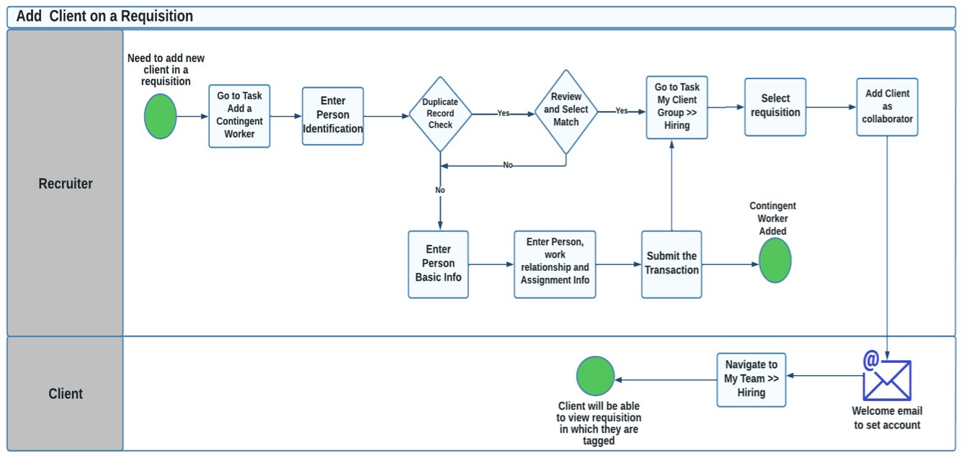

**Below table specifies the Add Contingent Worker process mapping to HCM process.**

|  |  |  |
| --- | --- | --- |
| Process Steps | Process Description | Process (System/  Manual) |
| **ADD_CONTINGENT_WORKER_01** | Recruiter has new client information | System |
| **ADD_CONTINGENT_WORKER_02** | While hiring, Recruiter Initiator can enter the personal details like – First Name, last Name and make changes while Adding Contingent Worker. | System |
| **ADD_CONTINGENT_WORKER_03** | Initiator can enter the basic assignment details like – Business unit (Region), Person type, Projected assignment end date etc. and can also make changes while Adding the Worker. | System |
| **ADD_CONTINGENT_WORKER_04** | In employment info, except Assignment status and business unit, rest other fields will be non-mandatory |  |
| **ADD_CONTINGENT_WORKER_07** | Contract Start date and contract End date will be added/viewed while adding the assignment information | System |
| **ADD_CONTINGENT_WORKER_08** | Once the HR creates client record as contingent worker in system, recruiter can add those client as one of the collaborators while creating a requisition | System |
| **ADD_CONTINGENT_WORKER_09** | Welcome email will be sent to the Client. | System |
| **ADD_CONTINGENT_WORKER_10** | Client will navigate to My Team >> Hiring to access requisition | System |
| **ADD_CONTINGENT_WORKER_11** | Clients will only be able to view those requisitions in which they have been tagged | System |

**Approval**

|  |  |  |  |  |  |  |
| --- | --- | --- | --- | --- | --- | --- |
| Country | Initiator | Approval Required | Condition | Approval 1 | Approval 2 | FYI |
| All Countries | Recruiter | No |  |  |  |  |

# Security

## Roles

|  |  |  |
| --- | --- | --- |
| **Role Name** | **Key Responsibility** | **Data Access** |
| ENERS Hiring Manager | - View own Requisition and below reporting hierarchy requisitions  - Create Requisition  - View Candidate Job Applications  - Move Candidate in Selection Process  - View Job Offer  - Create Job Offer  - Send Email  - Add Interaction  - Collect Feedback  - Manage Campaigns  Note: Will not be able to Search Candidate | * + Will be able to view all Job Requisitions raised by Hiring Manager and their direct reports   + Will be able to view candidate against raised requisitions |
| ES Division Head(Using recruiter job role) | - View all Requisitions  - Create Requisition  - Search all Candidates  - View Candidate Job Applications  - Move Candidate in Selection Process  - View Job Offer  - Create Job Offer  - Send Email  - Add Interaction  - Add to Candidate Pool  - Collect Feedback  - Manage Campaigns  -Add contingent worker | Will be able to see requisition which are assigned to them and in which they are added as collaborator type(Division Head/Hiring Manager) |
| ENERS Global Recruiter | - View all Requisitions  - Create Requisition  - Search all Candidates  - View Candidate Job Applications  - Move Candidate in Selection Process  - View Job Offer  - Create Job Offer  - Send Email  - Add Interaction  - Add to Candidate Pool  - Collect Feedback  - Manage Campaigns  -Add contingent worker | * + Will be able to view all Job Requisitions   + Will be able to view all Candidates |
| ENERS Country Recruiter | - View all Requisitions  - Create Requisition  - Search all Candidates  - View Candidate Job Applications  - Move Candidate in Selection Process  - View Job Offer  - Create Job Offer  - Send Email  - Add Interaction  - Add to Candidate Pool  - Collect Feedback  - Manage Campaigns  - Add contingent worker | * Will be able to view all Job Requisitions as per Recruiting AOR * Will be able to view all Candidates |
| ENERS Pending Worker | -Onboarding  -Personal Information  -Learning | Will be able to see own record |
| ENERS Recruiting Administrator | - Manage Content Library (Offers, Ad-hoc email templates, Statements, etc.)  - Manage Questions  - Manage Requisition Templates | Will be able to see all requisition |
| ENERS Collaborator | |  | | --- | | View Job Offer  View Candidate Job Application  View External Candidate Sensitive  Information  Update Candidate Job Application  View Job Offer Salary  View Job Requisition  Search for Candidates  View Job Offer Other Compensation | | Will be able to see and manage requisition and offer |
| ES Human Capital Management Integration Specialist | Create Removal Policy  Remove Personal Information |  |
| ENERS Client | View Job Requisition  View Candidate Job Application  View Internal Documents |  |

## Area of Responsibility

You can assign a responsibility to a person and define the scope of the responsibility by identifying the people for whom the person has the responsibility; the person then appears in the Work Contacts list of those people. You manage areas of responsibility using the Manage Areas of Responsibility task in the Person Management work area.

Assigning an area of responsibility doesn't affect the person records the representative can see. Access to records is controlled through security. Area of responsibility is used to assign the right representative based on the scope defined.

The different types of Area of Responsibility to be created in Fusion HCM are as follows:

|  |  |
| --- | --- |
| Area of Responsibility (AOR) | Scope |
| Recruiting | Country |
| Mobilization team | Z to A |

## Role Provisioning

Role provisioning is a functionality in Oracle HCM Cloud which allows to add the roles automatically to the newly hired member.

|  |  |
| --- | --- |
| Role | Provisioning Condition |
| ENERS Hiring Manager | To All Managers |
| ENERS Country Recruiter | As per Area of Responsibility |
| ENERS Pending Worker | To All Pending Workers |
| ENERS Collaborator | To All Mobilization team |

# Business Process

|  |  |
| --- | --- |
| **Business Process** | **To Be Implemented for** |
| Create Job Requisitions | Finland |
| Format and Post Job Requisitions | Finland |
| Source and Manage Candidates | Finland |
| Referral From Agent | Finland |
| Managing Candidate Pools | Finland |
| Managing Recruitment Campaigns | Finland |
| Refer Jobs | Finland |
| Search and Apply for Jobs | Finland |
| Manage Candidate Job Applications | Finland |
| Manage Interviews | Finland |
| Manage Job Offers | Finland |
| Manage Pre-boarding and Contract of Employment | Finland |
| Manage Security Clearance | Finland |

**Overall Recruitment Cycle for ENERS Hiring**

Oracle Recruiting Cloud provides one window for recruitment-related transactions. Overall Process flow for Recruitment is as follows:

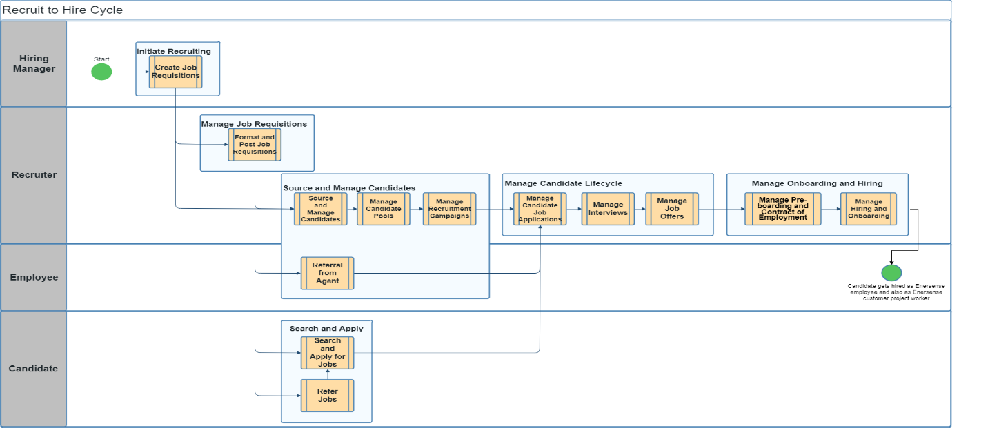

|  |  |  |
| --- | --- | --- |
| **Process Step** | **Process Description** | **System or Manual** |
| 01_Initiate_Recruiting | The hiring Manager identifies an open job and will initiate job requisition. | System |
|  | For ENERS hiring, hiring manager can use Recruiting Type as : Office Woker, Field Worker, Customer Project Worker and Trainee | System |
| 02_Initiate_Recruiting | Hiring a manager will fill in basic information and will only be able to save the requisition | System |
| 03_Manage_Job_Requisitions | The recruiter will receive a notification and check details of the requisition. Alternatively, a recruiter can initiate a requisition. | System |
| 04_Manage_Job_Requisitions | Once the requisition is filled out then the recruiter will submit it for approval. Based on the approval matrix, it is routed to the approvers | System |
| 05_Manage_Job_Requisitions | The approvers will receive a notification to review and give their decision on the job requisition. | System |
| 06_Manage_Job_Requisitions | Once the requisition is approved by all the respective approvers, an FYI notification is sent to the recruiter and the job requisition file is considered as Open. | System |
| 07_Manage_Job_Requisitions | Recruiter will perform job formatting and post it on different career sites | System |
| 08_Source_Candidates | The requisition is now ready for sourcing and candidate search. | System |
| 09_Source_Candidates | Recruiters can create pools and manage campaigns | System |
| 10_Referral_Agent | Recruiters can add Agents on a requisition (Currently not used) | System |
| 11_ Referral Agent | Agents can refer candidates and track requisition (Currently not used) | System |
| 12_Candidate_Cycle | Recruiter can manage candidate job applications | System |
| 13_Candidate_Cycle | The recruiter can manage interviews | System |
| 14_Candidate_Cycle | Recruiters can create and extend job offers | System |
| 15_Candidate_Cycle | Recruiter can move the candidate to HR, once candidate accepts offer | System |
| 16_Preboarding_Hiring | Recruiter can manage preboarding tasks and convert pending worker as an employee | System |
| 17_Preboarding_Hiring | Recruiters can manage hiring and onboarding tasks as well | System |
| 18_Search_and_Apply | Candidates can search and apply for jobs from external career sites | System |
| 19_Search_and_Apply | Employees can search and apply for a job from an internal career site | System |
| 20_Search_and_Apply | Employees can refer a job to a candidate and to another employee | System |

**Overall Recruitment Cycle for Client Hiring**

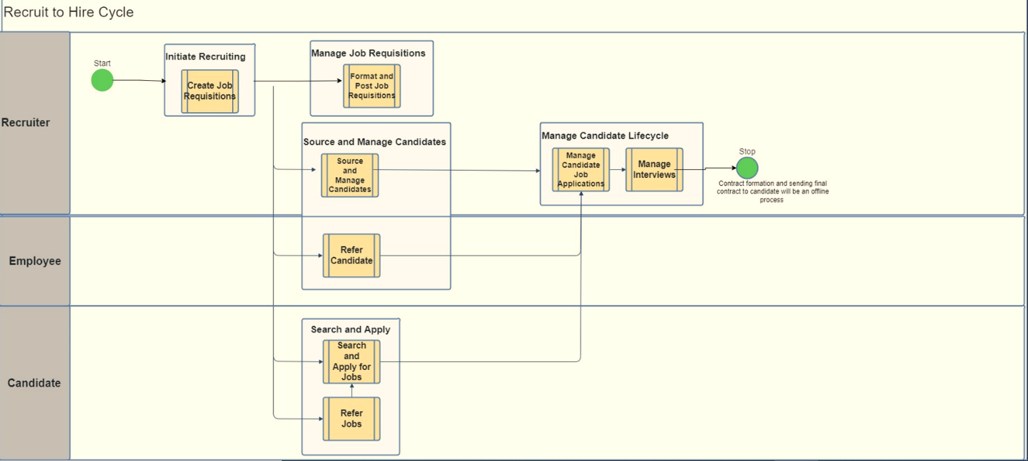

|  |  |  |
| --- | --- | --- |
| **Process Step** | **Process Description** | **System or Manual** |
| 01_Client_Hiring | Recruiter will initiate job requisition for client job opening and external project opening after gathering all information offline by sales team | System |
|  | For Client hiring, Recruiter will use Recruiting Type as External Project | System |
| 02_Client_Hiring | Recruiter will fill in and complete all job requisition details like basic details of the requisition like Recruiting type, Use (Job template, Standalone template, Existing, blank requisition), basic info, hiring team, basic details, posting details, attach interview questionnaires, prescreening question, candidate selection process | System |
| 03_Client_Hiring | For recruiting type as External Project, Recruiter will have to select Sales Group (which is client) as Collaborator for External Project opening. And select CSP as Pipeline which will not have offer and Move to HR phase and state | System |
| 04_Client_Hiring | Once the requisition is filled out then the recruiter will submit it for approval. Based on the approval matrix, it is routed to the approvers   In client hiring case, it is auto approved | System |
| 05_Client_Hiring | The approvers will receive a notification to review and give their decision on the job requisition. | System |
| 06_Client_Hiring | Recruiter will perform job formatting and post it on different career sites | System |
| 07_Client_Hiring | The requisition is now ready for sourcing and candidate search. | System |
| 08_Client_Hiring | Recruiter can manage candidate job applications | System |
| 09_Client_Hiring | The recruiter can manage interviews | System |
| 10_Client_Hiring | Candidates can search and apply for jobs from external career sites | System |
| 11_Client_Hiring | Employees can search and apply for a job from an internal career site | System |
| 12_Client_Hiring | Employees can refer a job to a candidate and to another employee | System |
| 13_Client_Hiring | Recruiter will mark job opening as filled and will also remove sales group (client name) from collaborator once job opening has been closed | System |

## Create Job Requisitions

Create Job Requisition Diagram

|  |  |  |
| --- | --- | --- |
| **Process** | **Process Description** | **System or Manual** |
| 01_Initiate_Job_Requisition | Hiring Manager can check the Vacant Jobs offline with HR team | Manual |
| 02_Initiate_Job_Requisition | If the Job Exists and has requirement to hire candidate then the manager can directly go to the Hiring work area to raise the Requisition.  **Note: If the Job does not exist then the hiring manager can get it created through Global HR.** | System |
| 03_Initiate_Job_Requisition | While requesting the requisition hiring manager can also fill in the basic details of the requisition like Recruiting type, Use (Job template, Standalone template, Existing, blank requisition), basic info, hiring team, basic details, posting details, attach interview questionnaires, prescreening question, candidate selection process and submit the requisition for approval. | System |
| 04_Job_Requisition_Approval | Approvals will happen as per the approval process. Approver can approve it or reject it. | System |
| 05_Job_Requisition_Approval | Once approved, the recruiter will receive notification for job formatting. Job requisition can now be formatted and posted on different sources by recruiter. Namely, Internal website, External website, Job Boards and Agents by recruiter. | System |
| 06_Job_Requisition_Approval | If it is not approved, the hiring manager can redraft a job requisition or reject job requisition | System |
| 07_Complete_Job_Requisition | After posting recruiters can also add the slots for the interview and select an interview panel. | System |
| 08_InitiateJob_Requisition | Recruiter will initiate job requisition for client job opening and external project opening after gathering all information offline by sales team | System |
| 09_Complete_Job_Requisition | Recruiter will fill in and complete all job requisition details like basic details of the requisition like Recruiting type, Use (Job template, Standalone template, Existing, blank requisition), basic info, hiring team, basic details, posting details, attach interview questionnaires, prescreening question, candidate selection process | System |
| 10_Complete_Job_Requisition | For recruiting type as External Project, Recruiter will have to select Sales Group (which is client) as Collaborator for External Project opening. And select CSP as Pipeline which will not have offer and Move to HR phase and state | System |
| 11_Complete_Job_Requisition | Recruiters will also have to add Mobilization team members as collaborators for initiating security checks for any Recruiting Type | System |
| 12_Complete_Job_Requisition | Recruiter will submit job requisition | System |
| 13_Job_Requisition_Approval | It will be auto approved for Customer project , external project (pipeline requisitions) else it will go under approval to hiring manager | System |
| 14_Complete_Job_Requisition | Recruiters can then format and post job requisition on different form at. | System | |
| 15_Complete_Job_Requisition | Recruiter will mark job opening as filled manually or system will automatically fill the requisition once number of job opening has been achieved/hired. To automat e filling of job requisition, Recruiter will have to select “Automatically Fill Requisition” as Yes | system |
| 15_Complete_Job_Requisition | Recruiter will also remove sales group (client name) from collaborator once job opening has been closed | System |

**Approval**

|  |  |  |  |  |  |
| --- | --- | --- | --- | --- | --- |
| Country | Initiator | Approval Required | Condition | Approval 1 | FYI |
| All Countries | Hiring Manager | Yes | Recruiting Type – All | Hiring Manager's Manager | Recruiter |
| All Countries | Country Recruiter | No | Recruiting type – Customer Project Worker | Auto approval |  |
| All Countries | Country Recruiter | Yes | Requisition Type!= Customer Project Worker | Hiring Manager | Recruiter |
| All Countries | Business HR/ Local HR/ Global HR | Yes | Recruiting Type – All | Hiring Manager | Recruiter |
| All Countries | Country Recruiter | No | Recruiting type – External Project | Auto Approved |  |

## Format and Post Job Requisitions

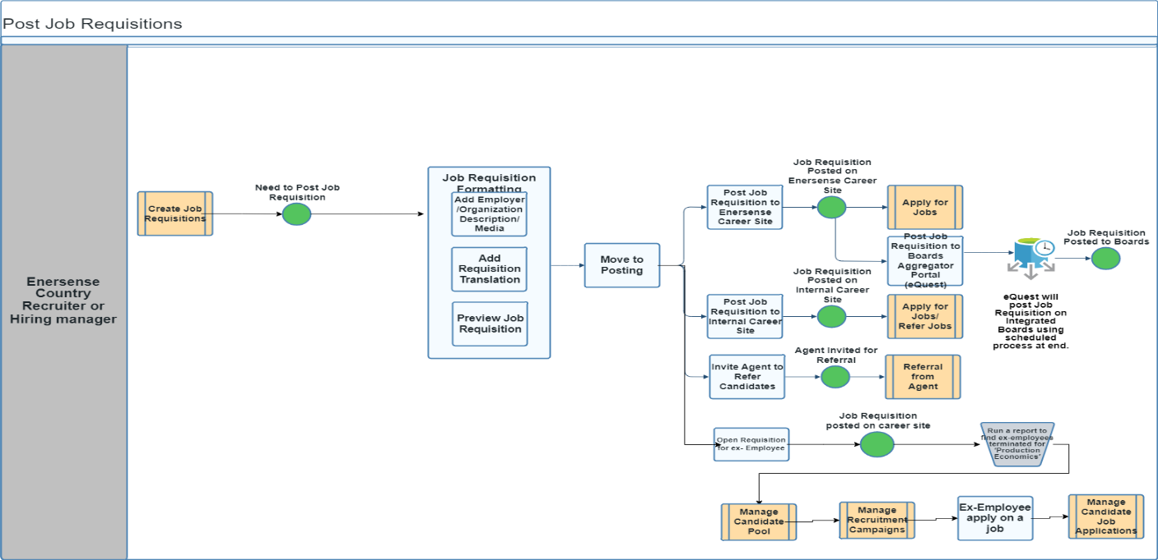

|  |  |  |
| --- | --- | --- |
| Process Step | Process Description | Process Type |
| 01_POST | Once requisition is approved, Recruiter or hiring manager will have option to format and post job opening | System |
| 02_POST | Recruiter will select Open for sourcing if they wish to open requisition only for ex-employee | System |
| 03_POST | Navigate to Job formatting area of the Requisition. If recruiter wish to open job for candidates and employee. | System |
| 04_POST | Add Employer description, Recruiting Organization description, add media (Image and Video) on job formatting page | System |
| 05_POST | Recruiter can also translate job requisition in different language | System |
| 06_POST | Recruiter can preview job requisition and move to posting | System |
| 07_POST | Navigate to Posting area of the Requisition. | System |
| 08_POST | Choose Posting Option on Internal career site or ENERS career site | System |
| 09_POST | Recruiter can send job requisition only for terminated employee and send them invite using campaign | System |
| 10_POST | Recruiter will navigate to Candidate pool and they can view Ex and layoff pool with all list of employees terminated with production economics reason. | System |
| 11_POST | Recruiter can send them job invitation by adding ex and layoff pool on campaign | System |
| 12_POST | Recruiter can even post job on job board aggregator portal (eQuest)  eQuest will post Job Requisition on Integrated Job Boards using scheduled process at eQuest end. | System |
| 13_POST | Recruiter can either Post Now or Post Later. | System |
| 14_POST | Recruiter will specify the expiration date. | System |
| 15_POST | External candidates will now be able to apply on jobs that have been posted on ENERS career site. | Manual |
| 16_POST | Internal employee will now be able to apply themselves on internally posted jobs or refer jobs to employee or candidate | System |
| 17_POST | Recruiter can also invite agents on job opening to refer candidate on jobs | Manual |

## Source and Manage Candidates

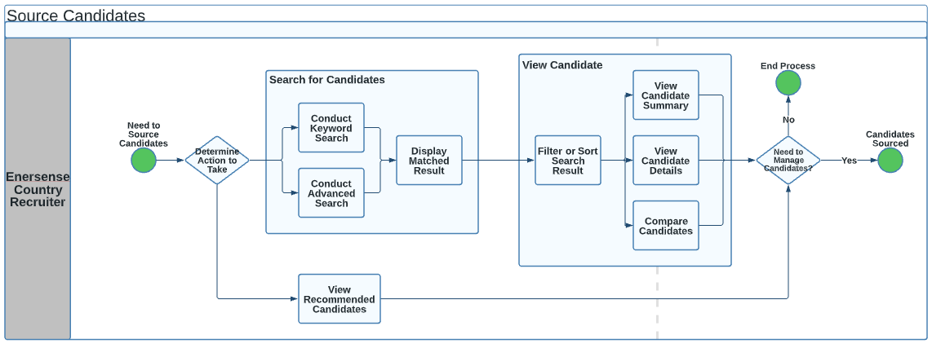

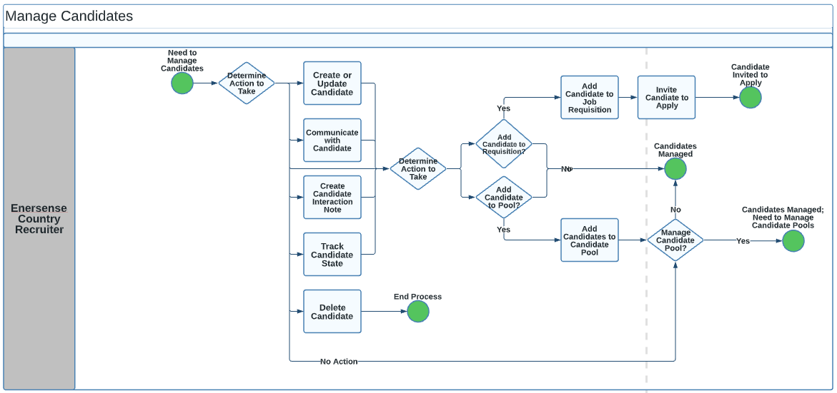

|  |  |  |
| --- | --- | --- |
| **Process** | **Process Description** | **System or Manual** |
| 01_Search_Candidates | Recruiters can also search for the candidates using keyword search or advanced search in the Talent pool and map them to the requisition. | System |
| 02_View_Candidates | Recruiter can filter and sort searched candidate | System |
| 03_View_Candidates | The recruiter can view the candidate summary, other details like address, personal details | System |
| 04_Search_Candidates | Recruiters can create new candidates in the system and map them to the requisition. | System |
| 05_Search_Candidates | Oracle AI application will give a list of all recommended candidates.  The recruiter can then view the candidate profile of all recommended candidates. | System |
| 06_Manage_Candidate | Recruiters can create candidate profiles in the system or view candidate applications on a posted job | System |
| 07_Manage_Candidate | Recruiter can track the state on which a candidate is (Screening/Interview/Offer) | System |
| 08_Manage_Candidate | Recruiter can delete candidate profile if candidate is not suitable for a job or move to another suitable job | System |
| 09_Manage_Candidate | Recruiters can add created candidates on a requisition or in a candidate pool | System |
| 10_Manage_Candidate | Recruiters can send invitations to apply for a job to manually created candidates.  Candidates will receive mail to apply | System |
| 11_Manage_Candidate | Recruiters can communicate with candidates. They can add interaction notes for candidates. | System |
| 12_Manage_Candidate | Recruiters can add candidates to a pool.  Recruiters can manage created pools and can manage candidates in a pool | System |

## Referral From Agent

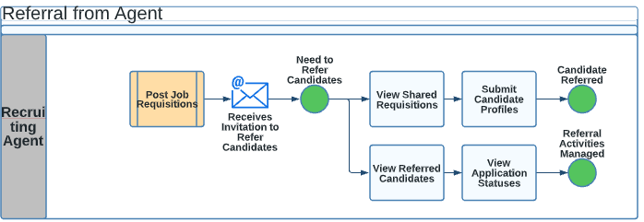

|  |  |  |
| --- | --- | --- |
| Process Step | Process Description | System/Manual |
| 01_AGENT | After posting job requisition, recruiter add agents | System |
| 02_AGENT | Agent receives invitation to refer candidates | System |
| 03_AGENT | Agents can view shared job requisition | System |
| 04_AGENT | Referrer will provide basic details such as Name, Contact Information and message to candidate under referral information section. | System |
| 05_AGENT | Referrer submits the referral and candidates will receive an email to view and provide more information to support their job application. | System |
| 06_AGENT | Members can also monitor the referral status. | System |

**Note:** ENERS is not going to use Agency Hiring but want this functionality incase required in the future

## Manage Candidate Pools

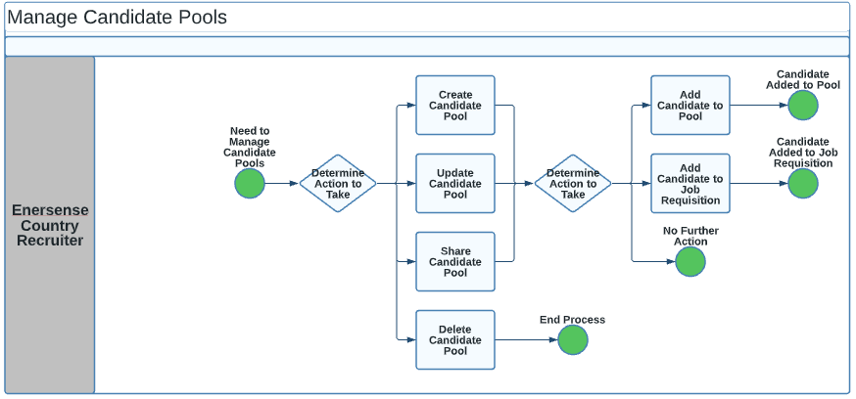

|  |  |  |
| --- | --- | --- |
| Process Step | Process Description | System/Manual |
| 01_CAND_POOL | Recruiters can create candidate pool, update pool details, share pool with other recruiters and can delete pool | System |
| 02_CAND_POOL | Recruiters can add candidates in a pool | System |
| 03_CAND_POOL | Recruiter can add candidate on a requisition | System |

* **Delivered Candidate Pool**

|  |  |  |
| --- | --- | --- |
| Pool name | Visibility | System delivered/ Custom |
| Talent Community | Global | System |
| Ex and layoff employee | Global | Custom |

## Manage Recruitment Campaigns

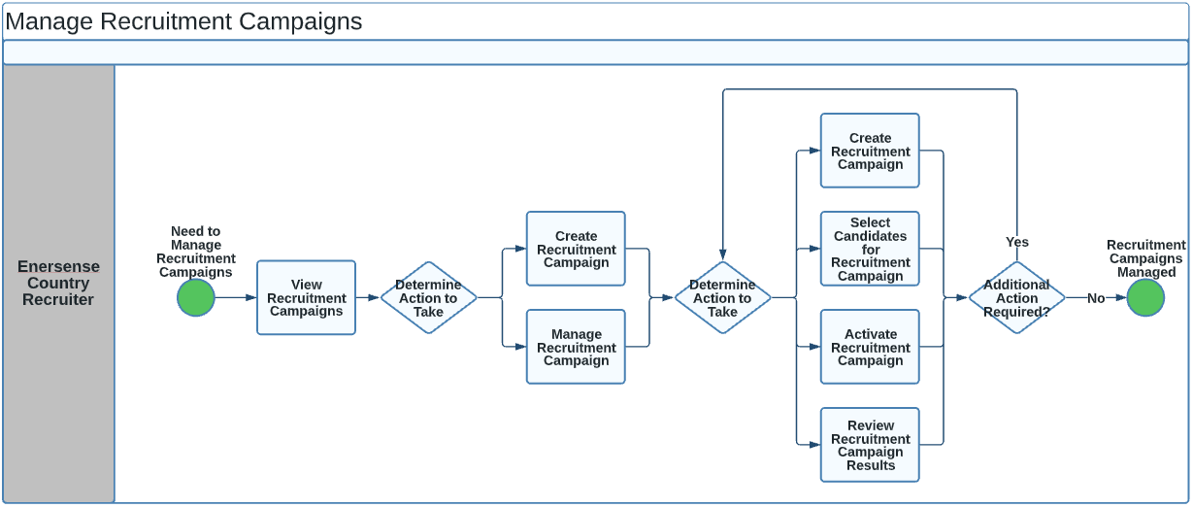

|  |  |  |
| --- | --- | --- |
| Process Step | Process Description | System/Manual |
| 01_REC_CAMP | Recruiters can create or manage campaigns to send job application email to all ex-employees terminated under the reason “Production Economics” within 6 months from current date | System |
| 02_REC_CAMP | Recruiters can add basic details, associate requisition to a campaign and add owners | System |
| 03_REC_CAMP | Recruiter can draft emails | System |
| 04_REC_CAMP | Recruiter can add audience criteria to add candidate on a requisition | System |
| 05_REC_CAMP | Recruiters have different audience criteria based on candidate type, location, education, work experience, candidate interaction and candidate pool | System |
| 06_REC_CAMP | Recruiter can select candidate for campaign | System |
| 07_REC_CAMP | Recruiters can post campaigns on different social media such as Facebook, twitter, LinkedIn | System |
| 08_REC_CAMP | Recruiter can activate campaign | System |
| 09_REC_CAMP | Recruiter can review campaign results | System |

## Refer Jobs

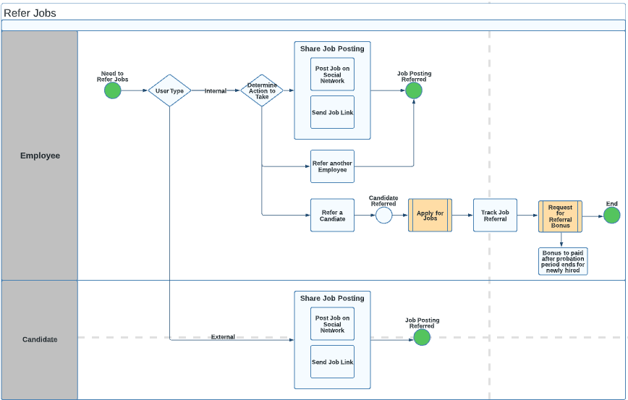

Note: Payments for Job Referral bonus needs to be done after probation period ends. (Finland and Lithuania) Estonia: half immediately and rest after probation period.

|  |  |  |
| --- | --- | --- |
| Process Step | Process Description | System/Manual |
| 01_REFER_JOBS | Once the requisition is posted on different networks. | System |
| 02_REFER_JOBS | Employees can send job links to other members | System |
| 03_REFER_JOBS | Employees can refer jobs to other employees once the job is posted on an internal career site | System |
| 04_REFER_JOBS | Employees can refer jobs to other candidates | System |
| 05_REFER_JOBS | Employees will provide basic details such as Name, Contact Information and message to candidate under referral information section. | System |
| 06_REFER_JOBS | For external candidates, the referrer can also attach files such as resume, cover letter, etc. | System |
| 07_REFER_JOBS | Referrer submits the referral and candidates will receive an email to view and provide more information to support their job application. | System |
| 08_REFER_JOBS | Employees can track their referrals | System |
| 09_REFER_JOBS | Employees can request a referral bonus | System |
| 10_REFER_JOBS | Payments for Job Referral bonus to be made after probation period ends for newly hired.  Finland and Lithuania: payment will be done after 6 months of probation period ends.  Estonia: half immediately paid and rest half after 4 months of probation end | System |
| 11_ REFER_JOBS | Referred candidates will be visible as Prospect in a job requisition | System |
| 12_REFER_JOBS | Recruiter will have to send Invite to these newly added prospect | System |
| 13_ REFER_JOBS | This invite will trigger mail to prospect candidates to apply to job opening through career site | System |

## Search and Apply for Jobs

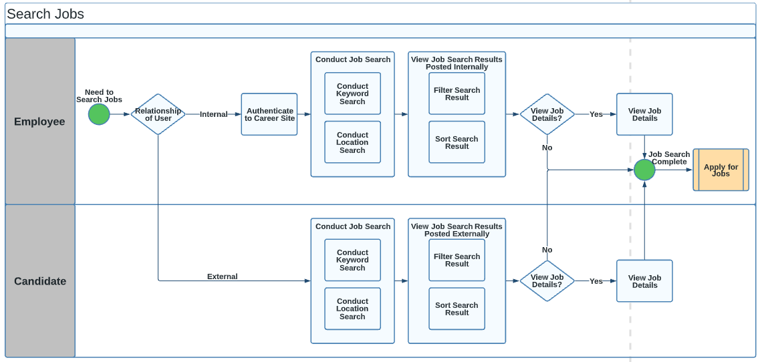

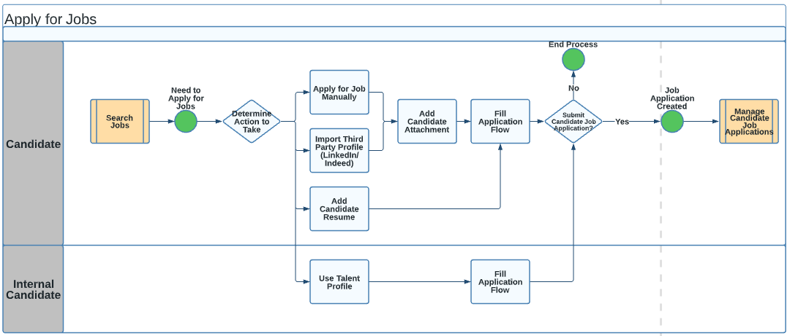

|  |  |  |
| --- | --- | --- |
| Process Step | Process Description | System/Manual |
| 01_APPLY_JOBS | Once the requisition is posted on different networks. | System |
| 02_APPLY_JOBS | Employees will search for job openings under an internal career site | System |
| 03_APPLY_JOBS | Employees can conduct keyword search, search by location | System |
| 04_APPLY_JOBS | Employees will view searched job | System |
| 05_APPLY_JOBS | Employee will Apply on internally posted job | System |
| 06_APPLY_JOBS | Employees will use talent profiles | System |
| 07_APPLY_JOBS | Employees can add skills and qualifications, languages | System |
| 08_APPLY_JOBS | Employees will fill in job application questions and submit the application.  Attachment will be mandatory (attach CV), if employee apply on customer project opening (external client positions) | System |
| 09_APPLY_JOBS | Job application will be completed for employee | System |
| 10_APPLY_JOBS | Candidates can search for a job that is posted externally | System |
| 11_APPLY_JOBS | Candidate can conduct keyword search, search by location | System |
| 12_APPLY_JOBS | Candidate will view searched job details | System |
| 13_APPLY_JOBS | Candidate will Apply for an externally posted job | System |
| 14_APPLY_JOBS | Candidate can manually apply for Job or candidate can either upload third party profile (LinkedIn/Indeed) | System |
| 15_APPLY_JOBS | Candidate will attach any document (resume/cover letter) | System |
| 16_APPLY_JOBS | Candidates will fill in job application questions and submit the application | System |
| 17_APPLY_JOBS | Job application will be completed for candidates | System |

## Manage Candidate Job Applications

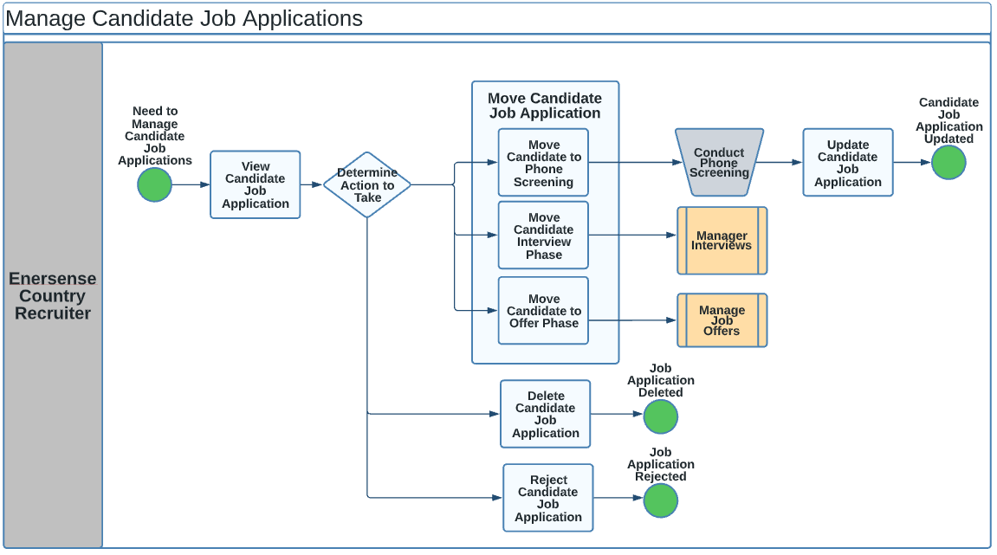

|  |  |  |
| --- | --- | --- |
| **Process Step** | **Process Description** | **System/Manual** |
| 01_CAND_APP | Candidate/Applicant will be landing at a new phase as soon as they apply. | System |
| 02_CAND_APP | Recruiter will move candidate to Screening phase (optional) | System |
| 03_CAND_APP | Recruiters can view the profile and conduct phone screening.  After screening is done, update job application to next phase by moving candidate to 1st interview. | System |
| 04_CAND_APP | The recruiters can then create the interview slots and then an automated interview invitation is sent to the candidate to select the available slots. | System |
| 05_CAND_APP | Interviewers and candidates receive notification on selected slots by the candidate | System |
| 06_CAND_APP | The recruiter can then collect feedback on interviews from interviewers and candidates (optional) | System |
| 07_CAND_APP | Once the candidate passed the 1st Interview, then moved to the next state: Interview – Reference check | System |
| 08_CAND_APP | This will trigger email notification to candidate to submit references details | System |
| 09_CAND_APP | Once the candidate passed the 1st Interview, then moved to the next state: Interview – Selected for Offer | System |
| 10_CAND_APP | On the above state, the national identifier of the candidate is collected as an attachment by sending system generated email to candidate | System |
| 11_CAND_APP | Candidates will receive email notification to submit NID as attachment | System |
| 12_CAND_APP | After collecting NID, recruiter will send offer to candidate by going on send message work area | System |
| 13_CAND_APP | After the candidate accepts the offer, the recruiter moves the candidate to the next state. | System |
| 14_CAND_APP | Recruiter will move candidate to Offer Accepted state | System |
| 15_CAND_APP | On the above state, the national identifier details of the candidate are collected by sending system generated email to candidate | System |
| 16_CAND_APP | Recruiter will move candidate to Request additional document state | System |
| 17_CAND_APP | This will trigger email notification to candidate to submit passport and other license and certificates | System |
| 18_CAND_APP | Recruiter will move candidate to Initiate Security clearance state | System |
| 19_CAND_APP | Recruiter will select send message to My Team to send security clearance message to mobilization team who are added as collaborator on a requisition | System |
| 20_CAND_APP | On successful passing of tests, recruiter will then move candidate to Offer phase | System |
| 21_CAND_APP | On the offer page, agreement is created by Recruiter in system using draft template and then recruiter saves the agreement, and then Recruiter will preview draft contract and download it | System |
| 22_CAND_APP | The recruiter will first send a draft version of the contract to the candidate via email (offline) | Manual |
| 23_CAND_APP | Once the candidate accepts the draft version of contract offline, then only final contract gets extended to candidate | System |
| 24_CAND_APP | On the offer page, final agreement is created by the Recruiter in system using final template and then recruiter submits the agreement, and then Recruiter will receive notification to extend that agreement to candidates. | System |
| 25_CAND_APP | Candidate receives email notification with link on it to either accept or reject final contract | System |
| 26_CAND_APP | Once the candidate accepts the offer, the candidate is considered selected. | System |
| 27_CAND_APP | Recruiter Move that candidate to HR Phase. Candidates will be converted to Pending Worker and pre-boarding tasks will kick off. | System |
| 28_CAND_APP | Recruiter can reject the candidate at any phase. | System |
| 29_CAND_APP | Recruiters can delete job applications if a candidate is not the best fit for a job. | System |
| 30_CAND_APP | For pipeline CSP, Recruiter will have to move candidate only till Interview Phase and State. Contract will be handled offline | System/Manual |

## Manage Interviews

|  |  |  |
| --- | --- | --- |
| **Process** | **Process Description** | **System or Manual** |
| 01_INTERVIEW | Recruiter will move the suitable candidate to interview phase and will schedule either Candidate Managed or Hiring Team Managed interview. | System |
| 02_INTERVIEW | To automatically send interview invite, recruiter need to add candidate managed interview on requisition | System |
| 03_INTERVIEW | Recruiter will fill in method of interview (phone, web conference, In person), time and interview panelist.  Recruiters can also add interview guidelines for interviewer to review | System |
| 04_INTERVIEW | The recruiter will then schedule the candidate's managed interview and will add slots on interview | System |
| 05_INTERVIEW | Recruiter will then move candidate to Interview – Scheduled state to automatically trigger interview invite | System |
| 06_INTERVIEW | Interview notification to schedule interview is sent to the candidate and candidate can select from the slots available. | System |
| 07_INTERVIEW | Recruiter needs to send Interview guidelines to candidate offline | Manual |
| 08_INTERVIEW | The internal candidate needs to inform the Line Manager about the interview | System |
| 09_INTERVIEW | Interviewers will receive information about the selected slots and interview details on a candidate through a notification | System |
| 10_INTERVIEW | Post interview, Recruiter can send the feedback form to the interviewers and to candidate | System |
| 11_INTERVIEW | Interviewer will receive notification to submit feedback on candidate | System |
| 12_INTERVIEW | They will respond and submit feedback | System |
| 13_INTERVIEW | Candidates will receive email (feedback questionnaire attached) to fill in the feedback form (Optional) | System |
| 14_INTERVIEW | Candidate will respond and submit feedback (Optional) | System |
| 15_INTERVIEW | As per the feedback response given by interviewers, recruiters can either reject the candidate, or directly move to offer process. | System |

## Manage Job Offers

Manage Job Offer Process Diagram

Note: Candidate to upload the National ID or any identification proof before extending the Job Offer.

|  |  |  |
| --- | --- | --- |
| Process Step | Process Description | System/Manual |
| 01_Offer_Process | Once the candidate has passed the 1st interview/Further Interview, an offer can now be created for them. | System |
| 02_Offer_Process | Candidate is moved to Interview – Selected for Offer, this will trigger an email notification to candidate asking their national identifier details | System |
| 03_Offer_Process | Once recruiter receives NID of candidate and check the ID, Recruiter can now take decision of sharing Job Offer | Manual |
| 04_Offer_Process | If Job Offer to be shared, recruiter will create and send job offer to candidate in send message work area | System |
| 05_Offer_Process | Candidate will receive email of shared job offer | System |
| 06_Offer_Process | Candidates may respond to job offers by sharing their response to the recruiter by sending email to the recruiter | Manual |
| 07_Offer_Process | If an offer is accepted by the candidate, the recruiter can then move the candidate to the next state of interview – Request Additional document | System |
| 08_Offer_Process | Candidates will now receive email notification to submit all documents (copy of passport, details of Education and Qualification Certificates, any cards) | System |
| 09_Offer_Process | Recruiter will be notified once documents have been submitted by candidate | System |
| 10_Offer_Process | The recruiter will verify all documents and can now move the candidate to the next state – Reference Check | System |
| 11_Offer_Process | Candidates will now receive email notification to submit reference check | System |
| 12_Offer_Process | The recruiter will be notified once references have been submitted by the candidate | System |
| 13_Offer_Process | Recruiter will now move candidate to next state – Initiate security clearance | System |
| 14_Offer_Process | Recruiter will now send message to mobilization team to initiate security clearance/Drug test by selecting send message to My Team as mobilization team is added as collaborator | System |
| 15_Offer_Process | Mobilization team will receive notification to initiate security test on a candidate | System |
| 16_Offer_Process | Mobilization team will initiate security clearance/Drug test and will wait for its result | Manual |
| 17_Offer_Process | If security clearance/drug test is not required or security clearance/Drug test has been cleared then recruiter can directly move candidate to Offer – To be created phase and state | System |
| 18_Offer_Process | Recruiter will now prepare an agreement for candidate on offer selection process. | System |
| 19_Offer_Process | The recruiter will prepare the agreement letter by filling in relevant details. The action for external candidates will be “Add Pending Worker” and the actions for internal candidates will be “Transfer, Global Transfer, Global Temporary Assignment, etc.”. | System |
| 20_Offer_Process | Recruiters will add the Assignment information which includes position, job, department etc., Salary information, Other Compensation, Offer Team (actual line manager as the hiring manager), attachments and agreement letter. | Manual |
| 21_Offer_Process | Any other documents apart from offer letter needs to be added in the “Candidate Documents”. If the recruiter wants to share any documents with the internal team, they can attach it in the “Internal Documents”. | System |
| 22_Offer_Process | Once the draft agreement letter is prepared, it will be saved. | System |
| 23_Offer_Process | Recruiter will first send draft contract to candidate | System |
| 24_Offer_Process | Recruiter will click on preview offer and then download the draft version of contract | System |
| 25_Offer_Process | The recruiter will then send a draft offer to the candidate offline via mail | Manual |
| 26_Offer_Process | Once the candidate accepts the draft contract then only the final contract will be extended to the candidate from the system | System |
| 27_Offer_Process | If a candidate rejects the draft contract, the recruiter can then negotiate the contract offline, make amendments and again redraft the agreement | Manual |
| 28_Offer_Process | Upon successful acceptance of the draft contract, the recruiter will now select the final contract template and submit it. | System |
| 29_Offer_Process | Final contract upon submission will be auto approved and this will now trigger email to hiring manager to sign contract with Docu-sign | System |
| 30_Offer_Process | Upon hiring manager’s signature, candidate will receive email to sign contract with DocuSign | System |
| 31_Offer_Process | If candidate reject final contract via mail, then the recruiter can either negotiate the agreement outside the system, make amendments and then again redraft the agreement and again send draft contract to the candidates.  Or recruiters can reject job applications | System |
| 32_Offer_Process | If security clearance/Drug test result gets failed then recruiter can reject job application of the candidate | System |
| 33_Offer_Process | Once the Agreement is accepted by the candidate, a mail notification will be sent to the recruiter of signed contract | System |
| 34_Offer_Process | Recruiter can now move the candidate to Accept Offer under Actions button in system | System |
| 35_Offer_Process | The recruiter will then move the candidate to HR phase. | System |
| 36_Offer_Process | This will trigger pre-onboarding tasks | System |

## Manage Pre-boarding and Contract of Employment

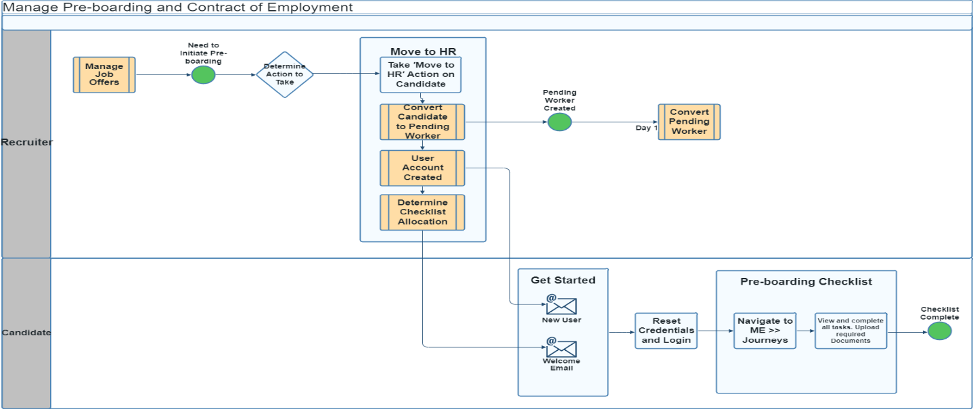

|  |  |  |
| --- | --- | --- |
| **Process** | **Process Description** | **System or Manual** |
| 01_Preboarding_Task | Once the candidate has accepted the offer, the recruiters can move them to Core HR. They will sit as pending workers. | System |
| 02_Preboarding_Task | A welcome email notification will be sent to the pending worker about the account creation. | System |
| 03_Preboarding_Task | Candidates will reset their credentials and login into the system | System |
| 04_Preboarding_Task | Once the candidate is moved to the HR state, the pre-boarding tasks will be triggered, and it will be assigned to the designated authorities. The notification will be sent regarding the tasks assigned. | System |
| 05_Preboarding_Task | Candidates will be able to see and complete all preboarding tasks assigned to them after they login to the system.  Candidate will navigate to ME >> Journeys  Candidate will able to see all tasks, complete tasks, upload required document as per checklist task,  Candidates will not be able to remove tasks. | System |
| 06_Preboarding_Task | Recruiters can add new tasks, reassign the existing tasks, and send reminders for the same. The managers can also perform the same. | System |
| 07_Preboarding_Task | On completion of the pre-boarding tasks and on the day of the hire the HR Team can perform the action of **“Convert Pending worker”.** If the pending worker does not join then people can **“Terminate the work relationship”** | System |
| 08_Preboarding_Task | Once the member is hired the new hire onboarding task gets triggered. The tasks can be adding personal details, accepting some policies, viewing introduction videos, etc. | System |

## Manage Security Clearance

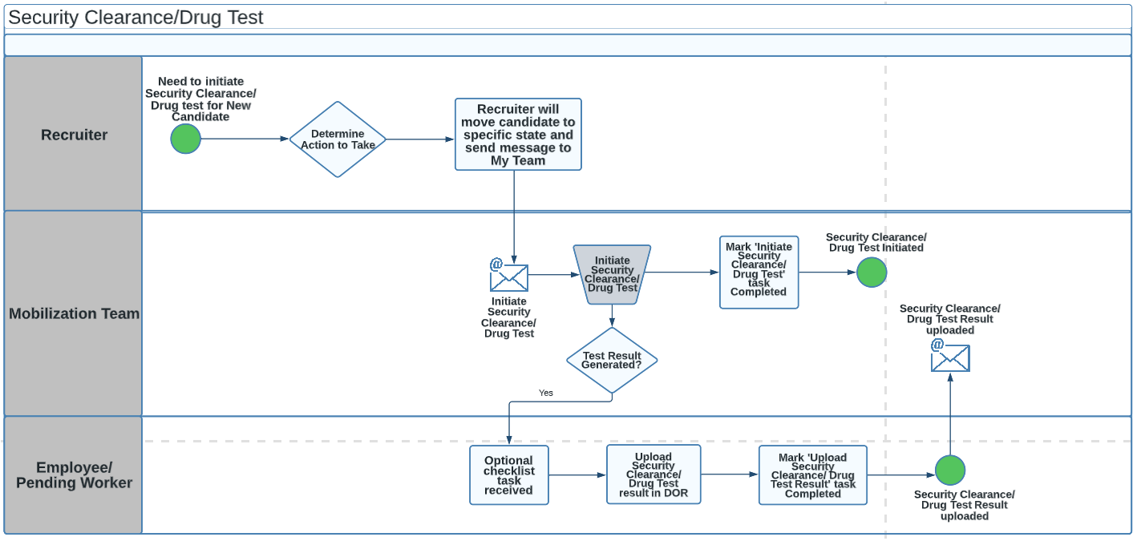

Note: If the security clearance/drug test/ Criminal Record is failed then contract will be Cancelled.

|  |  |  |
| --- | --- | --- |
| **Process** | **Process Description** | **System or Manual** |
| 01_Security_Clearance | Recruiter needs to initiate security clearance/drug test/ Criminal Record. | System |
| 02_Security_Clearance | Recruiter will move candidate on initiate security clearance/drug test/ Criminal Record state under Interview phase | System |
| 03_Security_Clearance | Recruiter will send message to My team under Actions button.  This will trigger notification to Mobilization team who are added as Collaborators on a requisition to initiate tests | System |
| 04_Security_Clearance | Mobilization team will then again send message to candidate to take their consent for initiating security clearance/drug test/criminal record | Manual |
| 05_Security_Clearance | Once the candidate fills in a consent form and submits it back to the logistics team via email. | Manual |
| 06_Security_Clearance | Mobilization team will take the task manually and wait for the response | Manual |
| 07_Security_Clearance | If security clearance is not required or the result of security clearance gets passed, then recruiter will move candidate to Offer Phase | System |
| 08_Security_Clearance | If the security clearance/drug test/ Criminal Record is failed then contract will be Cancelled. | System |
| 09_Security_Clearance | Mobilization team will initiate security task/drug test/criminal record. | Manual |
| 10_Security_Clearance | Mobilization team will mark the task as completed. | Manual |
| 11_Security_Clearance | If security task/drug test/criminal record test result is received by employee, employee will upload documents into the system as DOR in optional checklist task. | System |
| 12_Security_Clearance | Employees will mark uploaded security clearance/drug test result task as completed | System |
| 13_Security_Clearance | Test results will be uploaded as DOR in the system | System |
| 14_Security_Clearance | The mobilization team will receive notification of uploaded DOR of result submitted by employee. | System |

**Checklist FYI**

|  |  |  |  |  |  |
| --- | --- | --- | --- | --- | --- |
| Country | Initiator | Approval Required | Condition | Approval 1 | FYI |
| All Countries | Mobilization Team | No |  |  |  |
| All Countries | Employee | Yes |  |  | Mobilization Team |

Notification content to mobilization team: Project Information

## Purging Candidates data

As per GDPR Compliance, personal data of a candidate can be stored till the allowed period of time as per the rules.

Below are the 2 criteria for purging the details

* 2 years for candidates that have come in by applying
* People being let go as part of cooperation negotiations, the rehire clause is in effect for 6 months

Purging personal data of terminated employees is divided into 2 processes

### Creating Purging Policy

* Note: There will be 2 policies defined

1. Policy to remove Ex-employees terminated before 3 months with reason of production economics
2. Policy to remove candidate whose data is available since 2 years or more

### Remove Person Information

# Personalization

|  |  |  |  |
| --- | --- | --- | --- |
| **S.No** | **Task/Action** | **Details** | **Type** |
| 1 | Create/Edit Requisition | Remove work preferences section | Design Studio |
| 2 | Hiring manager candidate page view | Hiring manager can now access candidate Attachment section, Candidate Personal Information and Address details | Page composer |
| 3 | Hiring manager requisition page view | Hide Candidate Search | Structure |
| 4 | Requisition page view for Recruiter | Recruitment Dashboard | Page composer |
| 5 | Add Requisition Report | Integrate requisition report tab on hiring page | Page integration/Page composer |
| 6 | Modify Client view | Remove hyperlink to Resume, Attachment section, Activity, Interaction tab, Interview tab, Send message to team, Send message.  Remove candidate search, candidate pool, campaign, Job offer.  Hide candidate personal info (email and number), address info, sensitive info, national identifier, extra info, candidate name | Page composer/ roles, structure |
| 7 | DFF visibility on career site | Contract Type DFF created on requisition level is now visible on career site | HCM Design Studio |
| 8 | Gender visibility on career site | Candidate Application Diversity and Disability (Gender) is now visible on career site | HCM Design Studio |
| 9 | Update marketing message on career site | Changed to “I agree to receive company updates” | UIT |
| 10 | Mobilization team visibility having role of collaborator | Unhide attachment, personal information, address information of candidate | Page Composer |
| 11 | Enable date of birth | Enable DOB on job application flow | HCM Design Studio |
| 12 | Hide requisition template | Hide requisition template from basic information while creating job | HCM Design Studio |
| 13 | Recruiting Dashboard |  | Page Integration |

# 6.Reports

|  |  |  |  |  |
| --- | --- | --- | --- | --- |
| **Reports** | | | | |
| **Sr. No** | **Module** | **Custom report** | **Description** | **Report type** |
| 1 | Recruitment | Contract agreement | Replace the offer letter data model with more extensive details for contract agreement Ex. of fields out of scope:  Legal Entity identifier  Gross Salary | BIP |
| 2 | Recruitment | Adding candidates automatically in the 'Economic Production' Pool | Create a data model and an extract that adds the ex employees with recommended to rehire as 'Economic production withing 6 months from current date | BIP |
| 3 | Recruitment | employee agreement: Based on different Legislation | Report on employment agreement raised based on different LE | BIP |
| 4 | Recruitment | Purge data report: Ex-employees | Based on the GDPR constraint: 2 years | BIP |
| 5 | Recruitment | Purge data report: Ex-employees | Based on the GDPR constraint: 3 months | BIP |
| 6 | Recruiting dashboard | Overall recruitment dashboard | Based on data access | Standard |
| 7 | Requisition dashboard | Requisitions list | Based on data access | Standard |

7.Open Points

<https://evospira.evosysglobal.com/SpiraTest/322/Incident/Table.aspx>

|  |  |  |  |
| --- | --- | --- | --- |
| **Gap** | **Status-Owner** | **Spira Ticket and Update** | **Oracle SR** |
| 2) Career Site to be finalized | Open-ENERS | <Open Point IN:18438> |  |
| 6) Personal ID Card number to be finalized | Resolved | “ID Card” field is already available in Passport Type and we are going to use same |  |
| 7) Job boards (need equest or broadbean paid partnership) | Open | <Open Point IN:18069>  Quote has been sent and to be discussed internally between ENERS team members s |  |
| 8)To integrate office 365 in interview, ENERS to provide details | Open-ENERS | <Open Point IN:18080> |  |
| 9) Interview guideline document for Interviewers needs to be finalized | Open-ENERS | <Open Point IN:18300>  Point needs to be discussed with ENERS |  |
| 14) Oracle AI application | Resolved | <Open Point IN:20441>  Can view recommended candidates against a job requisition in production environment with minimum of 6 months consistent data |  |
| 15) Provide details of updated contract | Open-ENERS | Ulla to provide final and draft contract |  |
| 16) Enable Digital Assistant | Open-Evosys | <Open Point IN:20301> |  |
| 17) Draft Contract: To have watermark in all draft version | Open-ENERS | <Open Point IN:20316> |  |
|  | ENERS |  |  |
| 19) Recruiter LinkedIn account details for profile import on career site | Open-ENERS | <Open Point IN:20322>  <Open Point IN:22632> |  |
|  | ENERS |  |  |
| 21) Candidate Pool to be migrated | Open-ENERS | <Open Point IN:20429> |  |
| 25) Evosys to check to keep job requisition approval active for 3 months and later resend for approval | Open-Evosys | <Open Point IN:22601> |  |
| 26) Evosys To Check - if internal/ External jobs can be separated from referral jobs | Open-Evosys | <Open Point IN:22602> |  |
| 27) Evosys to check to remove New tag from career site once CSS has been applied | Open-Evosys | <Open Point IN:22603> |  |
| 31) Evosys to check to send notification recruiter/HR for contract projected end date | Open-Evosys | <Open Point IN:22631> |  |
| 33) Find - a common server area to upload guideline document for candidate to review before interview | Open-ENERS | <Open Point IN:22634> |  |
| 34) ENERS to provide with final Campaign email template | Open-ENERS | <Open Point IN:22635> |  |
| 35) Need to check with eQuest/ Broadbean on pricing | Open-ENERS | <Open Point IN:22810> |  |
| 36) Decision on digital signature: docusign/sharepoint | Open-ENERS | <Open Point IN:22811> |  |
| 37) Welcome Mail to Client | Open-Evosys | <Open Point IN:24863> |  |

# Sign Off

|  |  |
| --- | --- |
| ENERS | |
| Date of Issue: |  |
| Name of the Customer: | ENERS |
| Details of Agreement / Contract: |  |
| Brief description of deliverable: | This document presents the Solution Design for HCM modules which are in scope. |
| Period: |  |
| Date of delivery by Evosys: | 16-09-2022 |

**Legend**

* Yes (Y) response implies that the deliverable is approved.
* No (N) response implies that the deliverable is rejected with reasons and justification
* Yes, with Notes (YN) response implies that the deliverable is approved with the required modifications documented in its section.
* Remark: Stakeholder authorized personnel Sign-off shall not relieve the Vendor of his obligation to perform the work in accordance with the Contract document

|  |  |  |  |  |  |
| --- | --- | --- | --- | --- | --- |
| NO. | STAKEHOLDER NAME | POSITION | DEPARTMENT | SIGNATURE | SIGNED OFF  YES NO YN |
| 1. |  |  |  |  |  |
| 2. |  |  |  |  |  |

|  |
| --- |
|  |
| YES, WITH THE FOLLOWING NOTES ة |
| 1. |

|  |  |  |
| --- | --- | --- |
|  | Signature: ____________________ | Date: 16/09/2022 |